Deep Facial Diagnosis: Deep Transfer Learning From Face Recognition to Facial Diagnosis

In this paper author is using deep learning algorithm to detect disease from facial diagnosis as now-a-days due to so many diseases all hospitals are full which will not permit to see doctor sooner and this result into late diagnosis and to avoid such problem author is building neural network to predict disease from computer. Author is saying to train algorithm with small dataset will not give better prediction result so author is performing transfer learning with prebuilt VGG16 neural network.

In this transfer learning we can use any prebuilt neural network and then embed our own dataset training in the last layer of that prebuilt CNN algorithm. This algorithm is already trained with huge dataset so I embedding our small dataset in that prebuilt algorithm model can give better prediction result.

To implement this project author has used Disease Specific Face dataset to predict 4 types of diseases such as Beta-Thalassemia, Down syndrome, Hyperthyroidism and Leprosy. This dataset available only on IEEE website and they are asking 40$ to download that dataset so I downloaded some images related to above diseases from Google and then trained VGG16 classifier to predict diseases from faces.

In rest of the paper you can read details about diseases. Below screen shots showing dataset images used to train VGG16 algorithm.

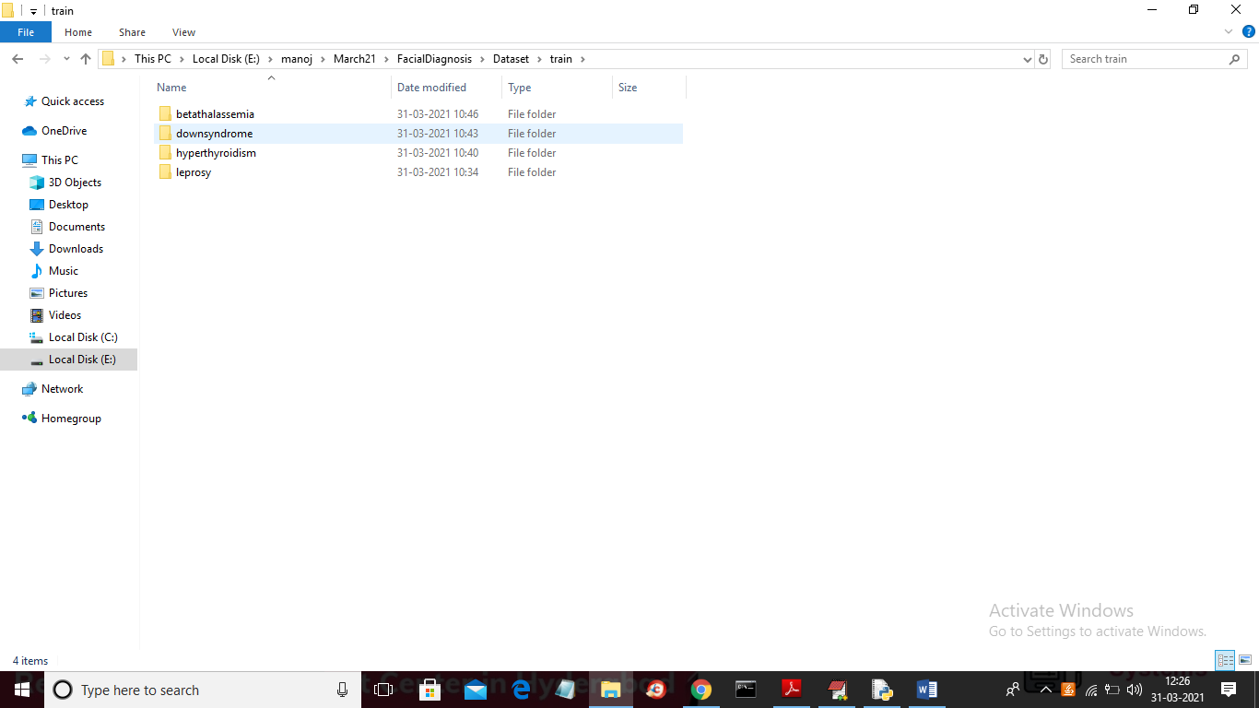

In above screen we have four folder for each disease and go inside any folder to see that disease face images

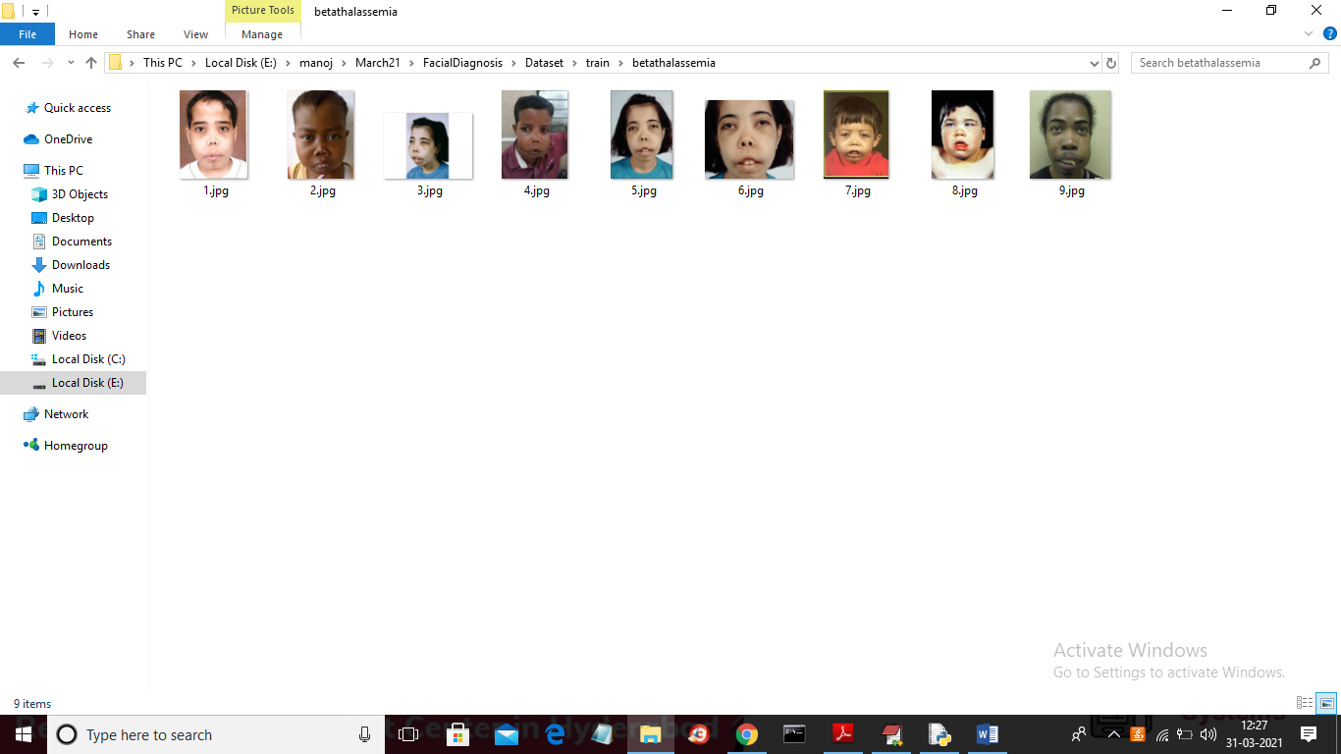

In each folder we will find faces related to that disease and above screen showing faces of ‘Beta-thalassemia’ disease.

SCREEN SHOTS

To run project double click on ‘run.bat’ file to get below screen

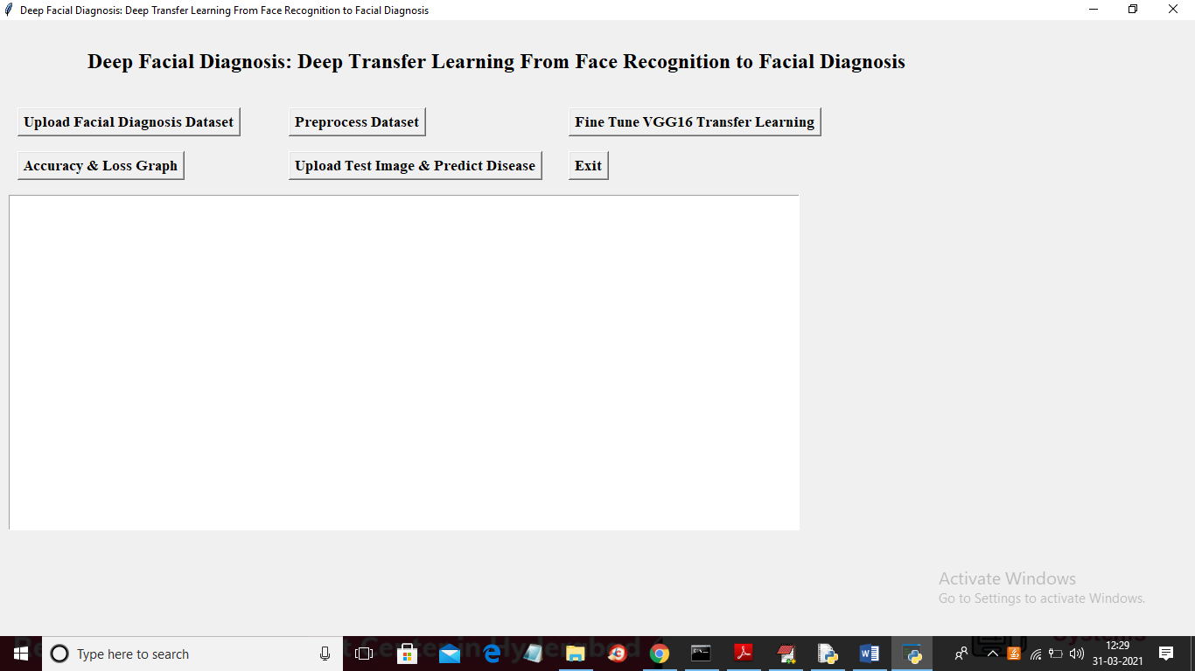

In above screen click on ‘Upload Facial Diagnosis Dataset’ button to upload dataset

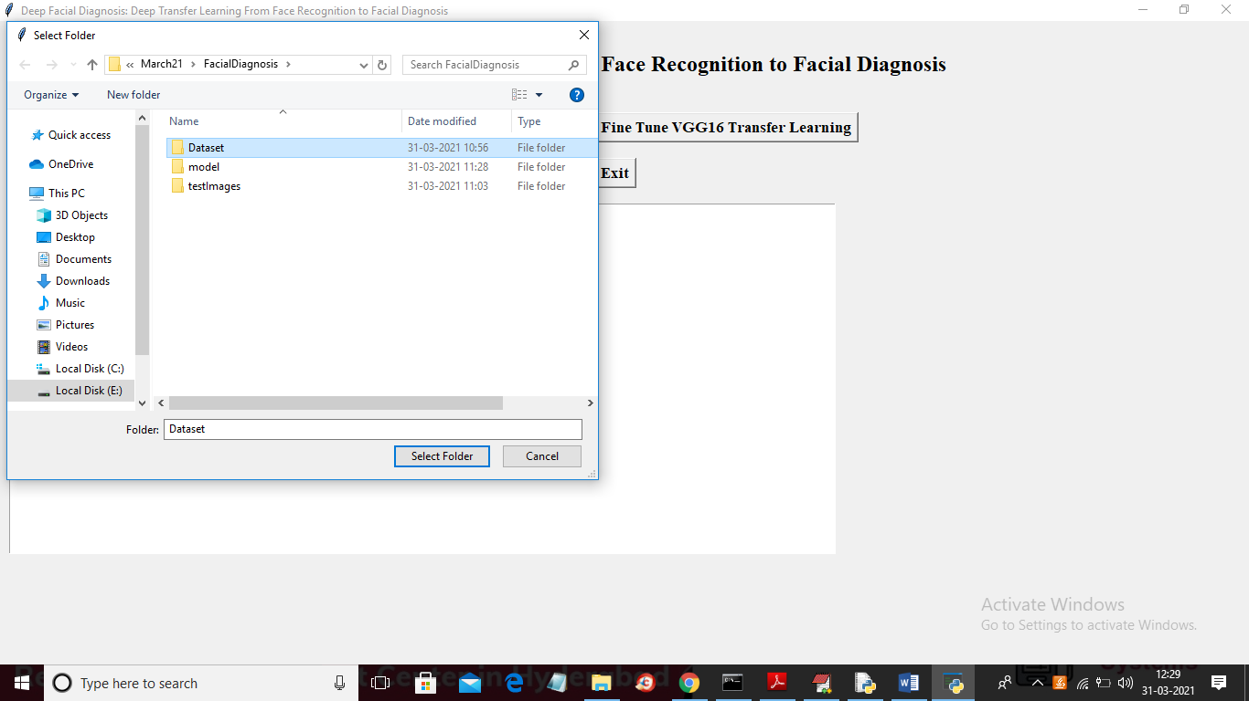

In above screen selecting and uploading ‘Dataset’ folder and then click on ‘Select Folder’ button to load dataset and to get below screen

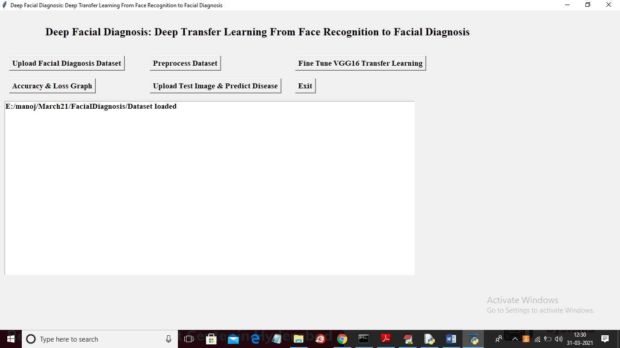

In above screen dataset loaded and now click on ‘Preprocess Dataset’ button to read images and then resize all images to convert to VGG16 compatible format

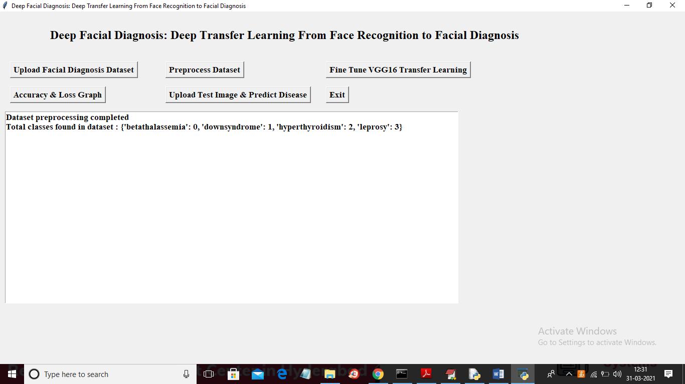

In above screen all images are process and then application find 4 different types of images and associated each image type with unique id or class label. Now dataset images are ready and now click on ‘Fine Tune VGG16 Transfer Learning’ button to build VGG16 model

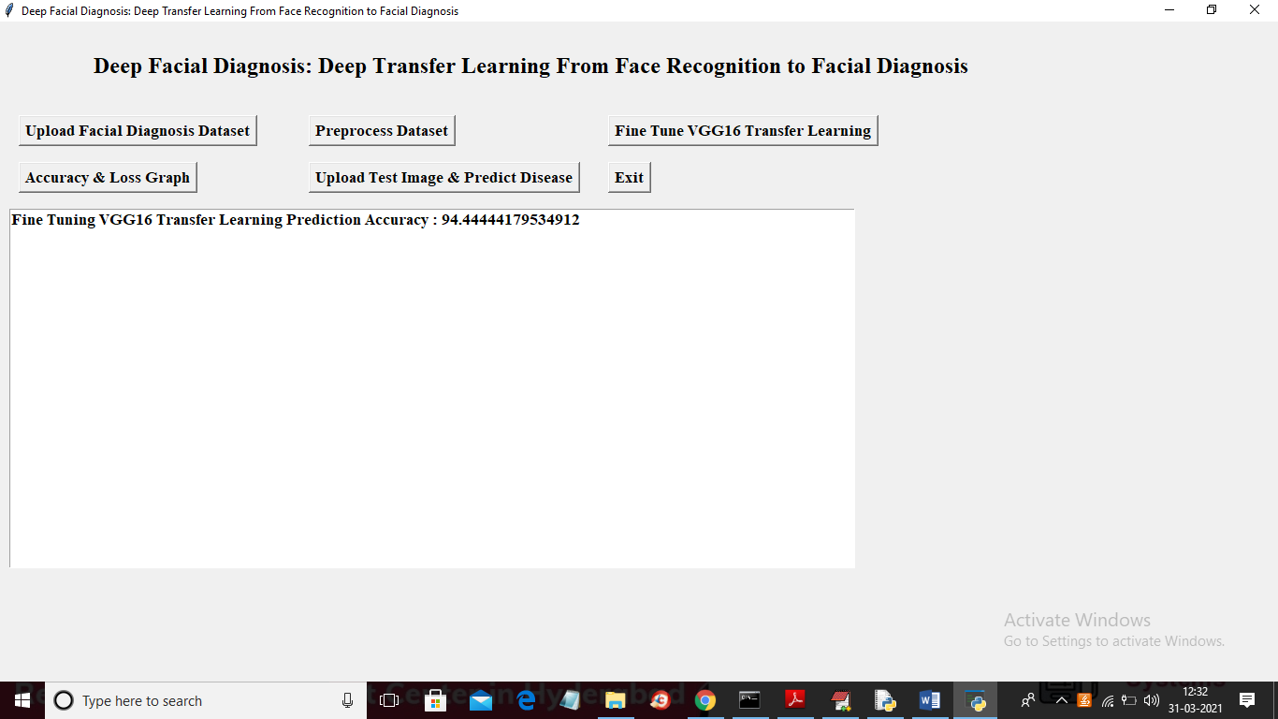

In above screen VGG16 model generated and its prediction accuracy is 94.44% and now VGG16 model is ready and now click on ‘Accuracy & Loss Graph’ to get below graph

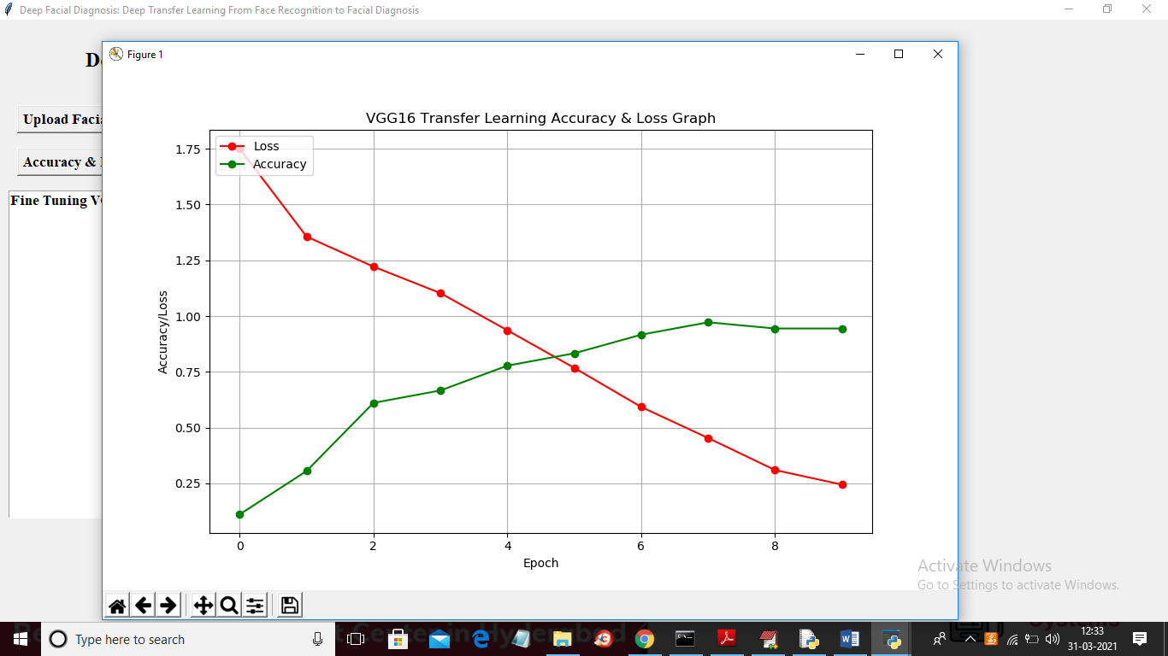

In above graph x-axis represents epoch and y-axis represents accuracy or loss value and in above graph red line represents loss and green line represents accuracy. In above graph we can see with each increasing epoch accuracy gets increase and better and loss get decrease. Now click on ‘Upload Test Image & Predict Disease’ button to upload test image and then VGG16 will predict disease from it

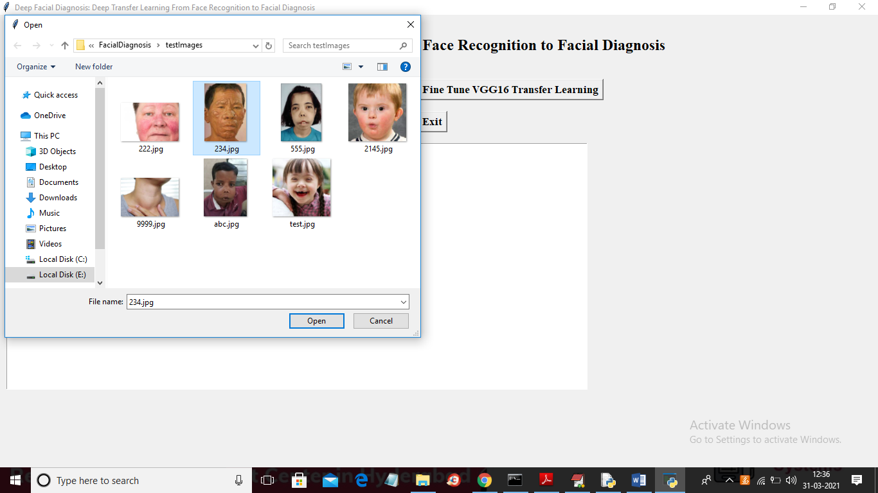

In above screen selecting and uploading ‘234.jpg’ file and then click on ‘Open’ button to get below result

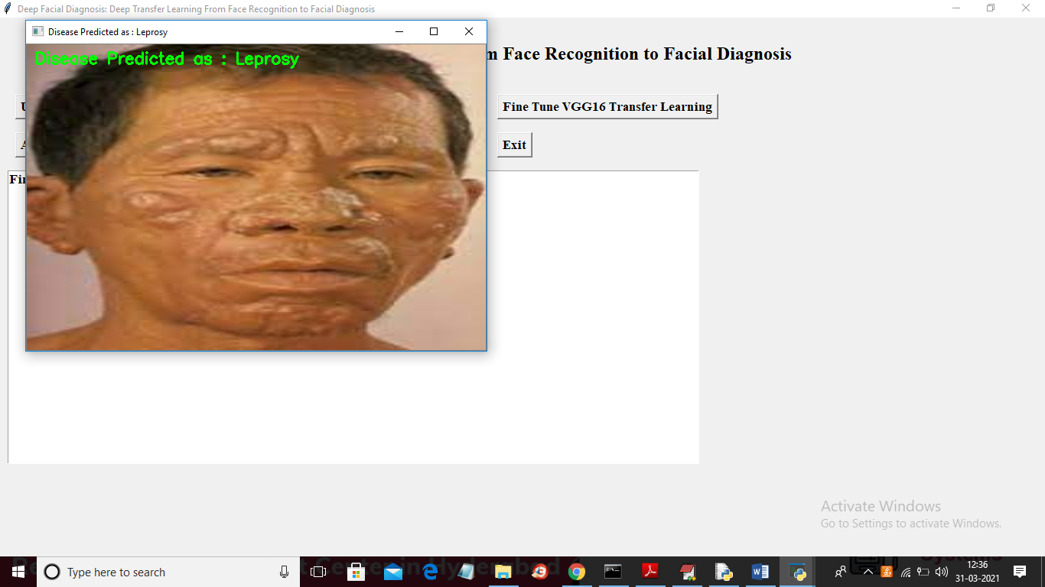

In above screen disease predicted as ‘Leprosy’ and now test another image

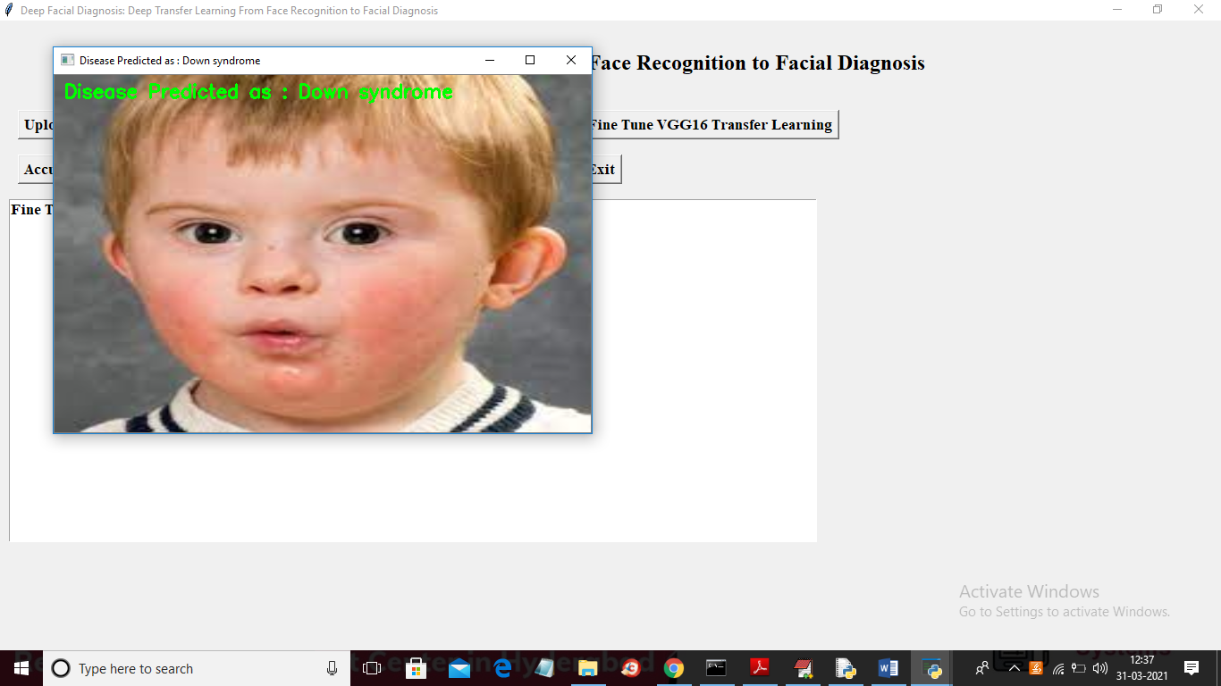

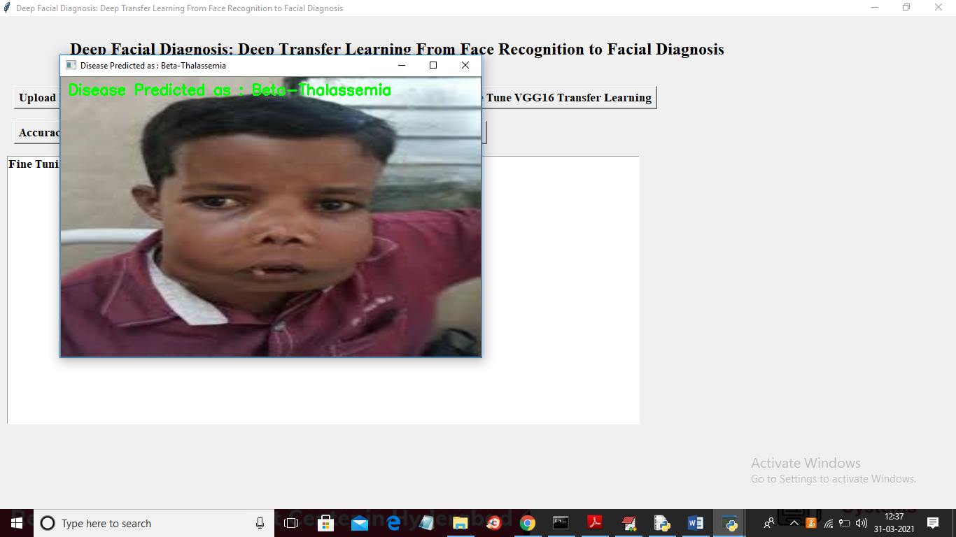

Similarly u can upload other images and test